

Hyper-V Management Pack Extensions 2012 R2

Authors:

**Cristian Edwards (CSS EMEA Private and Hybrid Clouds Technology Manager)**

**Diego Martinez Rellan (Microsoft Premier Field Engineer).**

MP Published: December 2013

Contents

Introduction 3

Document Version 3

Revision History 3

Supported Configurations 3

Prerequisites 4

Files in this Management Pack 4

Create a New Management Pack for Customizations 5

Groups 5

Understanding Hyper-V Management Pack Extensions 2012 R2. 6

Configuring the Hyper-V Management Pack Extensions 2012 R2 6

Inheritance Class Diagram 7

8

Objects the Management Packs Discover 9

Appendix: Monitors details 10

Target: Hyper-V MPE 2012 R2 Logical Processor 10

Target: Hyper-V MPE 2012 R2 SMB Share 10

Target: Hyper-V MPE 2012 R2 Virtual Machine Integration Services 10

Target: Hyper-V MPE 2012 R2 Virtual Machine VHDs 10

Target: Hyper-V MPE 2012 R2 Virtual Processor 11

Target: Server running Hyper-V 2012 R2 11

Target: Hyper-V 2012 R2 Virtual Machine 12

Appendix: Rules details 13

Target: Hyper-V MPE 2012 R2 Logical Processor 13

Target: Hyper-V MPE 2012 R2 SMB Share 13

Target: Hyper-V MPE 2012 R2 Virtual Machine VHDs 14

Target: Hyper-V MPE 2012 R2 Virtual Processor 14

Target: Server running Hyper-V 2012 R2 14

Target: Hyper-V 2012 R2 Virtual Machine 15

Target: Microsoft.Windows.HyperV.VirtualNetwork 15

Appendix: Views details 15

# Introduction

**This** [**Hyper-V Management Pack Extensions 2012 R2**](https://hypervmpe2012.codeplex.com) **is intended to add performance monitoring to the existing Hyper-*V* Management Pack.**

**This MP has monitors, rules and views that are detailed below. To avoid huge database consumption *most of the performance* rules are disabled by default. You can use these rules for creating your environment baselines.**

**Monitors are enabled and ready to run on your SCOM environment.**

**The configured thresholds on the monitors should cover most common scenarios but you may need to tune some of them to cover your own needs.**

**This MP is provided “as is” without any official support from Microsoft.**

## Document Version

This guide was written based on the **1.0.1.282** version of the Hyper-V MPE 2012 R2 Management Pack

## Revision History

|  |  |
| --- | --- |
| Release Date | Changes |
| December, 2013 | First Stable Version of Hyper-V MPE 2012 R2 |

## Supported Configurations

This management pack requires System Center 2012 SP1 – Operations Manager. A dedicated Operations Manager Management Groupis not required.

The Hyper-V MPE 2012 R2 supports the following operating systems:

* Windows Server 2012 R2.

***NOTE****: Windows Server 2012 – If you are running Hyper-V on 2012 OS version you will need to deploy the Hyper-V MPE 2012 version. Even though Hyper-V MPE 2012 and Hyper-V MPE 2012 R2 versions are almost equal, there are some changes in discoveries and monitors code. This guide is focused on Hyper-V MPE 2012* ***R2****.*

## Prerequisites

The Hyper-V MPE 2012 R2 for Windows Server 2012 R2 has the following requisites/dependencies:

* System Center 2012 SP1 Operations Manager.
* Management Packs required:
  + Windows Server Operating System v6.0.6989.0 or higher.
  + Windows Server Hyper-V 2012 R2 v7.1.10104.0 or higher.
  + Windows Server Cluster v6.0.7005.0 or higher

In the following image you can see the mp dependencies:

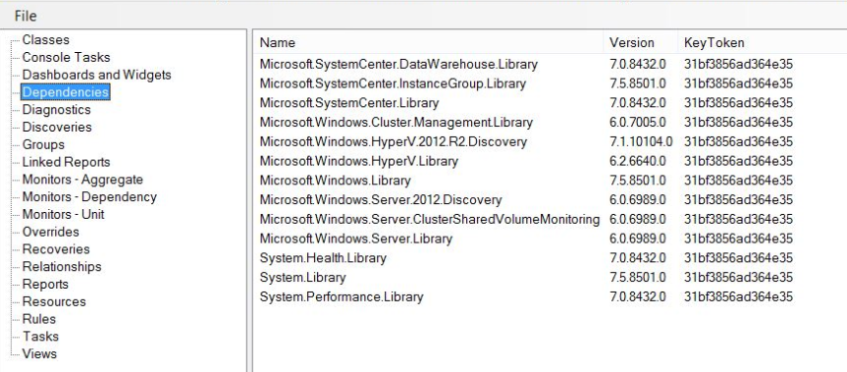

## Files in this Management Pack

The following table describes the files included in this management pack:

| **File** | **Display name** | **Description** |
| --- | --- | --- |
| HyperVMPE2012R2.mp | Microsoft Windows Hyper-V Extensions 2012 R2 | Contains classes, discoveries, groups, monitors, rules and views. |
| HyperVMPE2012R2.Dashboards.mp | Hyper-V MPE 2012 R2 Dashboards | Contains dashboards for VM Replica. |
|  | Hyper-V MP Extensions 2012 R2 Guide.docx | Management Pack Guide. |

## Create a New Management Pack for Customizations

The SQL Server Management Pack is sealed so that you cannot change any of the original settings in the management pack file. However, you can create customizations, such as overrides or new monitoring objects, and save them to a different management pack. By default, Operations Manager saves all customizations to the default management pack. As a best practice, you should instead create a separate management pack for each sealed management pack you want to customize.

Creating a new management pack for storing overrides has the following advantages:

• It simplifies the process of exporting customizations that were created in your test and pre-production environments to your production environment. For example, instead of exporting the default management pack that contains customizations from multiple management packs, you can export just the management pack that contains customizations of a single management pack.

• It allows you to delete the original management pack without first needing to delete the default management pack. A management pack that contains customizations is dependent on the original management pack. This dependency requires you to delete the management pack with customizations before you can delete the original management pack. If all of your customizations are saved to the default management pack, you must delete the default management pack before you can delete an original management pack.

• It is easier to track and update customizations to individual management packs.

For more information about sealed and unsealed management packs, see [Management Pack Formats](http://go.microsoft.com/fwlink/?LinkId=108355). For more information about management pack customizations and the default management pack, see [About Management Packs](http://go.microsoft.com/fwlink/?LinkId=108356).

To Create a New Management Pack for Customizations

|  |
| --- |
| 1. Open the Operations console, and then click the Administration button.  2. Right-click Management Packs, and then click Create New Management Pack.  3. Enter a name (for example, ADMP Customizations), and then click Next.  4. Click Create. |

## Groups

The following groups are added when you import the Hyper-V MPE 2012 R2 Management Pack:

* Hyper-V MPE 2012 R2 Cluster Servers Running Hyper-V 2012 Windows Computer Group
* Hyper-V MPE 2012 R2 Primary VMs Group
* Hyper-V MPE 2012 R2 Replica VMs Group
* Hyper-V MPE 2012 R2 Server Running Hyper-V 2012 R2 Windows Computer Group
* Hyper-V MPE 2012 R2 Standalone servers with Hyper-V 2012 R2 Windows Computer Group
* Hyper-V MPE 2012 R2 Replica Extended VMs Group

# Understanding Hyper-V Management Pack Extensions 2012 R2.

## Configuring the Hyper-V Management Pack Extensions 2012 R2

By default all monitors except the “Hyper-V MP” 2012 R2 Virtual TLB Flushes (Non-Optimized Video Card)” are enabled. The configured monitors are optimized to avoid high network utilization and to detect most common performance problems without generating too much alerts. The way we achieve that is creating **consecutive samples monitors**. This will ensure that alerts are only generated after some samples that are above the threshold in a period of time. The SCOM agents will upload the information to the SCOM server only when the alerts conditions are met. If no issue is detected the SCOM agent will not upload the data to the SCOM server optimizing the network utilization.

If default thresholds are not meeting your requirements you will need to adjust the number of samples, the frequency and maybe the thresholds.

Remember that these monitors are created to cover the most common performance problems scenarios.

We highly recommend to tune the MP if you need to change the default monitors configuration. This will ensure that your changes remain if a new version of this MP is released.

Remember that monitors performance information is not saved in the SQL database to generate performance reports against them. You should use the performance rules on this MP if your intention is to create your environment performance baseline

## Inheritance Class Diagram

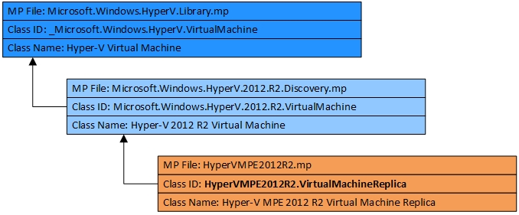

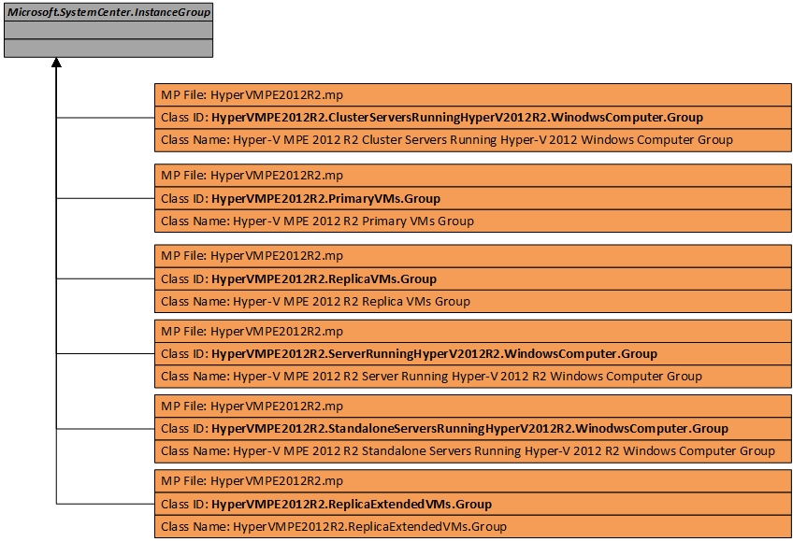

## 

## Objects the Management Packs Discover

The MPs discover the object types described in the following table. All discoveries are enabled by default.

| **Class / Object Type** | **Discovery** | **Target** | **Interval Seconds** |
| --- | --- | --- | --- |
| Hyper-V MPE 2012 R2 Logical Processor | Hyper-V MPE 2012 R2 Logical Processor Discovery | Microsoft.Windows.HyperV.2012.R2.ServerRole | 86400 |
| Hyper-V MPE 2012 R2 SMB Share | Hyper-V MPE 2012 R2 SMB (Powershell) Discovery | Microsoft.Windows.HyperV.2012.R2.ServerRole | 43200 |
| Hyper-V MPE 2012 R2 Virtual Machine Integration Services | Hyper-V MPE 2012 R2 Virtual Machine Integration Services Script Discovery | Microsoft.Windows.HyperV.2012.R2.Virtual Machine | 43200 |
| Hyper-V MPE 2012 R2 Virtual Machine Replica | Hyper-V MPE 2012 R2 Virtual Machine Replica Script Discovery | Microsoft.Windows.HyperV.2012.R2.ServerRole | 3600 |
| Hyper-V MPE 2012 R2 VMs VHDs | Hyper-V MPE 2012 R2 Virtual Machines VHDs (Powershell) Discovery | Microsoft.Windows.HyperV.2012.R2.VirtualMachine | 86400 |
| Hyper-V MPE 2012 R2 Virtual Processor | Hyper-V MPE 2012 R2 Virtual Processor (Powershell) Discovery | Microsoft.Windows.HyperV.2012.R2.VirtualMachine | 86400 |

# Appendix: Monitors details

### Target: Hyper-V MPE 2012 R2 Logical Processor

|  |  |
| --- | --- |
| **Name** | Hyper-V MPE 2012 R2 % Hypervisor Run Time (Critical) | (Warning) |
| **Aggregate** | Performance Health |
| **Description** | For guest VM’s this is the percentage of time the guest VP is running in hypervisor code on an LP or for the _Total the total across all guest VP’s. For the root this is the percentage of time the root VP is running in hypervisor code on an LP |

|  |  |
| --- | --- |
| **Name** | Hyper-V MPE 2012 R2 % Total Run Time |
| **Aggregate** | Performance Health |
| **Description** | This analysis checks the processor utilization of physical processors of the host computer. The "\Hyper-V Hypervisor Logical Processor(*)\% Total Run Time" performance counter is more accurate than using the "% Processor Time" counter on the host, root partition computer because the "% Processor Time" counter only measures the processor time of the host, root partition computer only. The "\Hyper-V Hypervisor Logical Processor(*)\% Total Run Time" performance counter is the best counter to use to analyze overall processor utilization of the Hyper-V server. |

|  |  |
| --- | --- |
| **Name** | Hyper-V MPE 2012 R2 Context Switches/Sec |
| **Aggregate** | Performance Health |
| **Description** | It is the number of context switches made for switching out/in the VM Virtual Processors. This does not keep into account the number of context switches made by the threads running in the host Operating System. |

### Target: Hyper-V MPE 2012 R2 SMB Share

|  |  |
| --- | --- |
| **Name** | Hyper-V MPE 2012 R2 SMB Share Clients (Latency Avg. sec/Data Request) |
| **Aggregate** | Custom |
| **Description** |  |

### Target: Hyper-V MPE 2012 R2 Virtual Machine Integration Services

|  |  |
| --- | --- |
| **Name** | Hyper-V MPE 2012 R2 Virtual Machine Integration Services Version. |
| **Aggregate** | Custom |
| **Description** | This monitor checks if the VM integration services is up to date compared with his Hyper-V host. |

### 

### Target: Hyper-V MPE 2012 R2 Virtual Machine VHDs

|  |  |
| --- | --- |
| **Name** | Hyper-V MPE 2012 R2 VHD Error Count Monitor |
| **Aggregate** | Availability Health |
| **Description** | There are two Hyper-V storage counter sets because of how storage works in Hyper-V. In Hyper-V we provide two virtual storage buses for VM’s. One is IDE and one is SCSI. The Virtual IDE counters show up in the “Hyper-V Virtual IDE Controller” counter set unless Integration Services are loaded and then you will see the activity for both virtual IDE and SCSI in the “Hyper-V Virtual Storage Device” counter set. If you don’t have integration services installed the only the “Hyper-V Virtual IDE Controller” will show the VM disk activity.  The Error count should always be zero for the virtual storage device. |

### Target: Hyper-V MPE 2012 R2 Virtual Processor

|  |  |
| --- | --- |
| **Name** | Hyper-V MPE 2012 R2 Virtual Processor (%Guest Run Time) |
| **Aggregate** | Performance Health |
| **Description** | This monitor checks the processor utilization of guest, virtual computer processors. The "\Hyper-V Hypervisor Virtual Processor(*)\% Guest Run Time" performance counter is more accurate than using the "% Processor Time" counter within the virtual computer due to clock calculation drift. |

### Target: Server running Hyper-V 2012 R2

|  |  |
| --- | --- |
| **Name** | Hyper-V MPE 2012 R2 CSV Volume (Read | Write) latency |
| **Aggregate** | Custom |
| **Description** |  |

|  |  |
| --- | --- |
| **Name** | Hyper-V MPE 2012 R2 Dynamic Memory Balancer Average Pressure (Critical) | (Warning) |
| **Aggregate** | Performance Health |
| **Description** | This gives you a very simple view of the overall memory allocation of your system. As long as this counter is under 100, there is enough memory in your system to service your virtual machines. Ideally this value should be at 80 or lower. The closer this gets to 100, the closer you are to running out of memory. Once this number goes over 100 then you can pretty much guarantee that you have virtual machines that are paging in the guest operating system.  <http://blogs.msdn.com/b/virtual_pc_guy/archive/2010/09/01/looking-at-dynamic-memory-performance-counters.aspx> |

|  |  |
| --- | --- |
| **Name** | Hyper-V MPE 2012 R2 SLAT Address Space (SLAT CPU) |
| **Aggregate** | Performance Health |
| **Description** | Windows Server 2008 R2 Hyper-V supports a new feature named Second Level Address Translation (SLAT). SLAT leverages AMD-V Rapid Virtualization Indexing (RVI) and Intel VT Extended Page Tables (NPT) technology to reduce the overhead incurred during virtual to physical address mapping performed for virtual machines. Through RVI or EPT respectively, AMD-V and Intel VT processors maintain address mappings and perform (in hardware) the two levels of address space translations required for each virtual machine, reducing the complexity of the Windows hypervisor and the context switches needed to manage virtual machine page faults. With SLAT, the Windows hypervisor does not need to shadow the guest operating system page mappings. The reduction in processor and memory overhead associated with SLAT improves scalability with respect to the number of virtual machines that can be concurrently executed on a single Hyper-V server. As an example, the Microsoft Remote Desktop Services (RDS) team recently blogged about performance tests conducted using an internal simulation tool on a Windows Server 2008 Terminal Services configuration running as a virtual machine on Windows Server 2008 R2 Hyper-V. The results showed that a SLAT-enabled processor platform increased the number of supported sessions by a factor of 1.6 to 2.5 when compared with a non-SLAT processor platform. Overall, Microsoft reports that with SLAT-enabled processors, the Windows hypervisor processor overhead drops from about 10% to about 2%, and reduces memory usage by about 1 MB for each virtual machine.  <http://www.virtualizationadmin.com/articles-tutorials/microsoft-hyper-v-articles/general/second-level-address-translation-benefits-hyper-v-r2.html> |

|  |  |
| --- | --- |
| **Name** | Hyper-V MPE 2012 R2 Virtual Machine Health Summary (Failed VMs) |
| **Aggregate** | Performance Health |
| **Description** | This monitor detects if your VMs are in failed state |

|  |  |
| --- | --- |
| **Name** | Hyper-V MPE 2012 R2 Virtual Machines Summary (Stopped VMs) |
| **Aggregate** | Performance Health |
| **Description** | This monitor detects if your VMs are stopped or not. In some scenarios you will want to be sure that your VMs are always running |

|  |  |
| --- | --- |
| **Name** | Hyper-V MPE 2012 R2 Virtual TLB Flushes (Non-Optimized Video card) |
| **Aggregate** | Performance Health |
| **Description** | Video card drivers tend to use memory access methods that cause Hyper-V to need to clear out the CPU cache for memory page table mapping a lot. This is an expensive thing to do in Hyper-V at the best of times.  <http://blogs.msdn.com/b/virtual_pc_guy/archive/2009/11/16/understanding-high-end-video-performance-issues-with-hyper-v.aspx> |

### Target: Hyper-V 2012 R2 Virtual Machine

|  |  |
| --- | --- |
| **Name** | Hyper-V MPE 2012 R2 Dynamic Memory Average Pressure (Critical) | (Warning) |
| **Aggregate** | Performance Health |
| **Description** | A virtual machine with a pressure of 100 has exactly the amount of memory that it needs (this is equivalent to a memory availability of 0%). If the virtual machine pressure goes over 100 it has less memory than it needs (equivalent to a negative memory availability) and if the virtual machine pressure is under 100 then the virtual machine has more memory than it needs.  <http://blogs.msdn.com/b/virtual_pc_guy/archive/2010/09/01/looking-at-dynamic-memory-performance-counters.aspx> |

|  |  |
| --- | --- |
| **Name** | Hyper-V MPE 2012 R2 NUMA Remote Pages |
| **Aggregate** | Performance Health |
| **Description** | Every VM in Hyper-V has a default NUMA node preference. Hyper-V uses this NUMA node preference when assigning physical memory to the VM and when scheduling the VM’s virtual processors. A VM runs best when the virtual processors and the memory that backs the VM are both on the same NUMA node, since such “remote” memory access is significantly slower than “local” access |

|  |  |
| --- | --- |
| **Name** | Hyper-V MPE 2012 R2 Virtual Machine Snapshots |
| **Aggregate** | Custom |
| **Description** | This monitor checks if your Virtual Machine has snapshots (checkpoints) in your environment |

# Appendix: Rules details

The intention of this MP is not only to monitor the performance for troubleshooting purposes. Rules included in this MP will help you create you Hyper-V hosts performance baselines. All performance rules are disabled by default because they could impact the network performance and OpsMgr database size.

### Target: Hyper-V MPE 2012 R2 Logical Processor

|  |  |  |  |  |
| --- | --- | --- | --- | --- |
| **Name** | **Category** | **Object Name** | **Counter Name** | **Frequency** |
| Hyper-V MPE 2012 R2 Logical Processor (Context Switches/Sec) | Performance | Hyper-V Hypervisor Logical Processor | Context Switches/sec | 1800 |
| Hyper-V MPE 2012 R2 % Hypervisor Run Time | Performance | Hyper-V Hypervisor Logical Processor | % Hypervisor Run Time | 1800 |
| Hyper-V MPE 2012 R2 % Total Run Time | Performance | Hyper-V Hypervisor Logical Processor | % Total Run Time | 300 |

### Target: Hyper-V MPE 2012 R2 SMB Share

|  |  |  |  |  |
| --- | --- | --- | --- | --- |
| **Name** | **Category** | **Object Name** | **Counter Name** | **Frequency** |
| Hyper-V MPE 2012 R2 SMB Client Shares Avg. Data Queue Length | Performance | SMB Client Shares | Avg. Data Queue Length | 900 |
| Hyper-V MPE 2012 R2 SMB Client Shares Avg. sec/Read | Performance | SMB Client Shares | Avg. sec/read | 900 |
| Hyper-V MPE 2012 R2 SMB Client Shares Avg. sec/Write | Performance | SMB Client Shares | Avg. sec/Write | 900 |
| Hyper-V MPE 2012 R2 SMB Client Shares Data Requests/Sec | Performance | SMB Client Shares | Data Requests/sec | 900 |

### Target: Hyper-V MPE 2012 R2 Virtual Machine VHDs

|  |  |  |  |  |
| --- | --- | --- | --- | --- |
| **Name** | **Category** | **Object Name** | **Counter Name** | **Frequency** |
| Hyper-V MPE 2012 R2 Virtual Storage Device Read Bytes/Sec | Performance | Hyper-V Virtual Storage Device | Read Bytes/sec | 300 |
| Hyper-V MPE 2012 R2 Virtual Storage Device Writes Bytes/Sec | Performance | Hyper-V Virtual Storage Device | Write Bytes/sec | 300 |

### Target: Hyper-V MPE 2012 R2 Virtual Processor

|  |  |  |  |  |
| --- | --- | --- | --- | --- |
| **Name** | **Category** | **Object Name** | **Counter Name** | **Frequency** |
| Hyper-V MPE 2012 R2 % Guest Run Time | Performance | Hyper-V Hypervisor Virtual Processor | % Guest Run Time | 300 |

### Target: Server running Hyper-V 2012 R2

|  |  |  |  |  |
| --- | --- | --- | --- | --- |
| **Name** | **Category** | **Object Name** | **Counter Name** | **Frequency** |
| Hyper-V MPE 2012 R2 Context Switches/Sec | Performance | System | Context Switches/sec | 300 |
| Hyper-V MPE 2012 R2 Live Migrations Failures | Alert |  |  |  |
| Hyper-V MPE 2012 R2 Network Interface Bytes Sent | Performance | Network Interface | Bytes Sent/sec | 300 |
| Hyper-V MPE 2012 R2 Network Interface Received | Performance | Network Interface | Bytes Received/sec | 300 |
| Hyper-V MPE 2012 R2 NUMA Node Page Count | Performance | Hyper-V VM Vid Numa Node | PageCount | 300 |
| Hyper-V MPE 2012 R2 NUMA Node Processor Count | Performance | Hyper-V VM Vid Numa Node | ProcessorCount | 300 |
| Hyper-V MPE 2012 R2 Processor Queue Length | Performance | System | Processor Queue Length | 300 |
| Hyper-V MPE 2012 R2 Virtual Network Adapter Bytes/Sec | Performance | Hyper-V Virtual Network Adapter | Bytes/sec | 300 |

### Target: Hyper-V 2012 R2 Virtual Machine

|  |  |  |  |  |
| --- | --- | --- | --- | --- |
| **Name** | **Category** | **Object Name** | **Counter Name** | **Frequency** |
| Hyper-V MPE 2012 R2 Dynamic Memory VM (Physical Memory) | Performance | Hyper-V Dynamic Memory VM | Physical Memory | 300 |
| Hyper-V MPE 2012 R2 Dynamic Memory VM (Guest Visible Physical Memory) | Performance | Hyper-V Dynamic Memory VM | Guest Visible Physical Memory | 300 |

### Target: Microsoft.Windows.HyperV.VirtualNetwork

|  |  |  |  |  |
| --- | --- | --- | --- | --- |
| **Name** | **Category** | **Object Name** | **Counter Name** | **Frequency** |
| Hyper-V MPE 2012 R2 Virtual Switch Bytes/Sec | Performance | Hyper-V Virtual Switch | Bytes/sec | 300 |

# Appendix: Views details

# 